Robotic Swarm Control and the game *Tilt* Dr. Aaron T. Becker & the Robotic Swarm Control Lab

https://www.youtube.com/user/aabecker5

* Move sliders by tilting game grid. On each move, all sliders must move downhill as far as they can go
* When all green sliders (and none of the blue sliders) have fallen through the exit hole, **you win!**

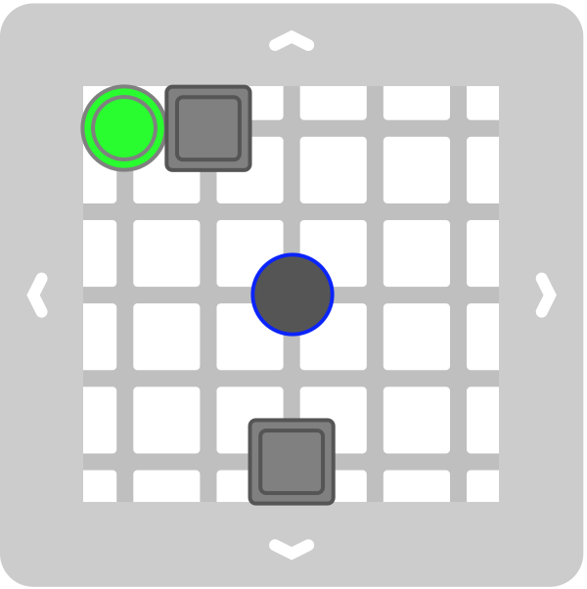

Challenge 1: **Write down a winning sequence (🡸,🡹,🡺,🡻)**



Challenge 2: **Write down a winning sequence (🡸,🡹,🡺,🡻)**

youtube.com/user/aabecker5

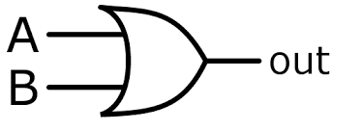

Challenge 3: **Write down a winning sequence (🡸,🡹,🡺,🡻)**

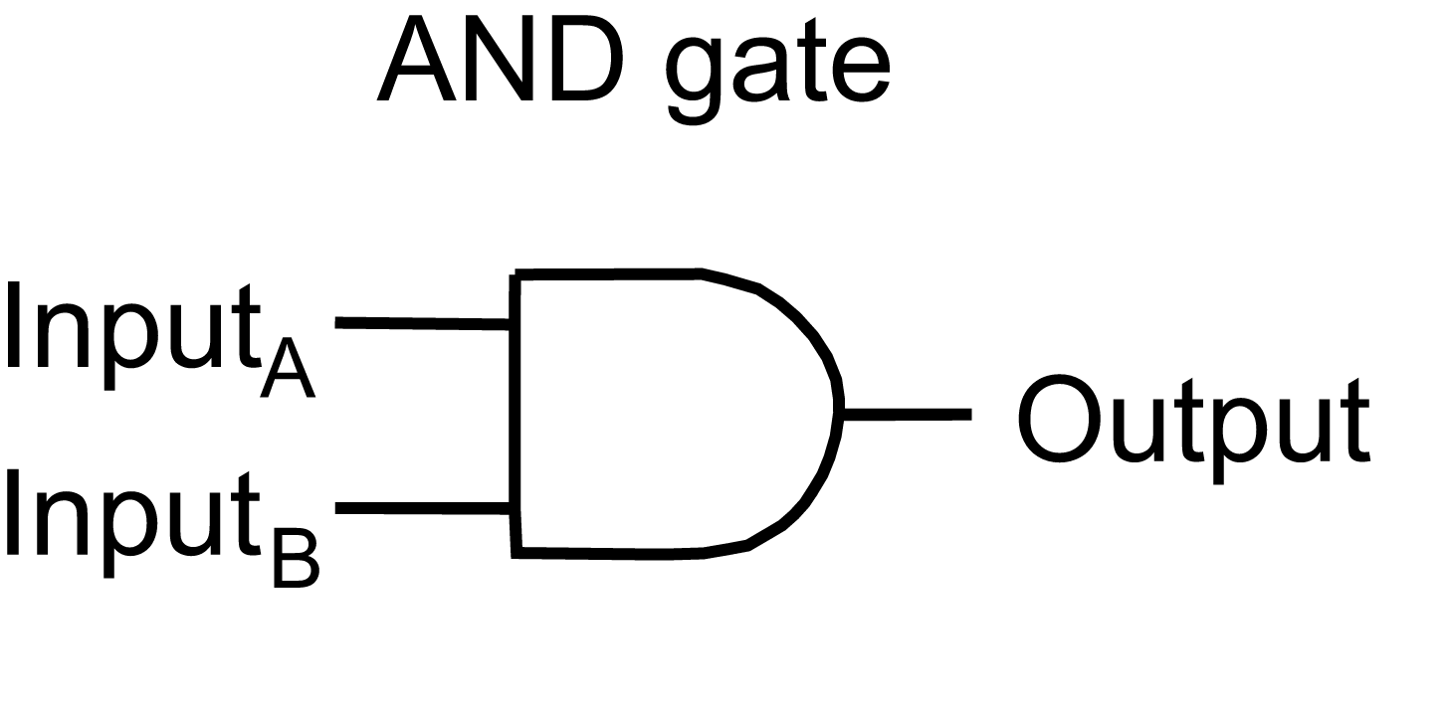Challenge 4: **Design a game board**

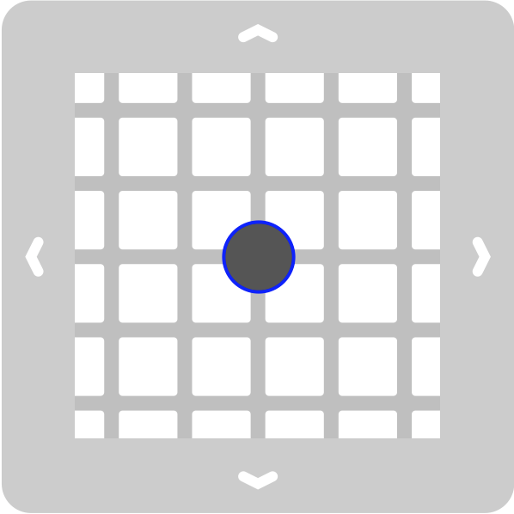

A B